MID-SEMESTER PROGRESS REPORT
Time-Series Data Analysis and Trend Discovery in Pakistan’s Crop Prices

Group Members | • Taha Nawaz (23L-2644)  • Ali Ahmad (23L-2619)  • Shahzeb Imran (23L-2506) | Date | March 29, 2026
Course | Data Mining | Deliverable | Deliverable 1

1. Project Overview
Agricultural price volatility is a persistent challenge for farmers, policymakers, and market participants in Pakistan. Prices of essential crops fluctuate due to a complex interplay of seasonal cycles, supply-demand dynamics, and climatic factors. This project addresses this challenge through time-series data mining applied to the Crop Prices Dataset of Pakistan (Kaggle), containing historical price records across multiple markets with attributes including crop type, city, date, and price.
The core objective is to systematically discover and model seasonal patterns, long-term trends, and abnormal price fluctuations using a structured pipeline: data engineering, exploratory analysis, time-series decomposition, and forecasting using ARIMA and Holt-Winters Exponential Smoothing. Model accuracy is evaluated with MAE, RMSE, and MAPE on a chronologically correct train-test split, aiming to produce interpretable insights that support agricultural planning and market forecasting.

2. Dataset at a Glance
Total Records | Unique Cities | Unique Crops | Source Files
~7.99 Million | 138 | 76 | 53 CSV Files
Date Range | Avg Price (PKR) | Price Std Dev | Max Price (PKR)
2008 – 2024 | 5,475 | 6,484 | 97,850

3. Milestones Achieved

M1 — Data Loading & Merging
Loaded and validated all 53 CSV files, applied schema checks, date parsing, numeric coercion, and merged them into a single unified dataset of ~7.99 million records, sorted chronologically per crop-city pair.

M2 — Preprocessing & EDA
Applied IQR-based outlier filtering, duplicate removal, calendar feature extraction, and StandardScaler normalization. Nine visualizations were generated covering distributions, seasonality, volatility, and cross-city/crop comparisons.

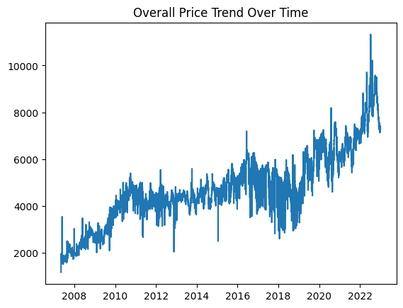  Fig 1. Price Trend Over Time | 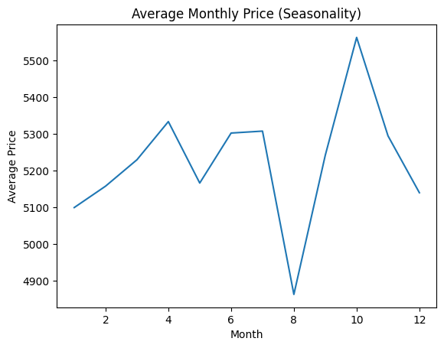  Fig 2. Monthly Seasonality Pattern | 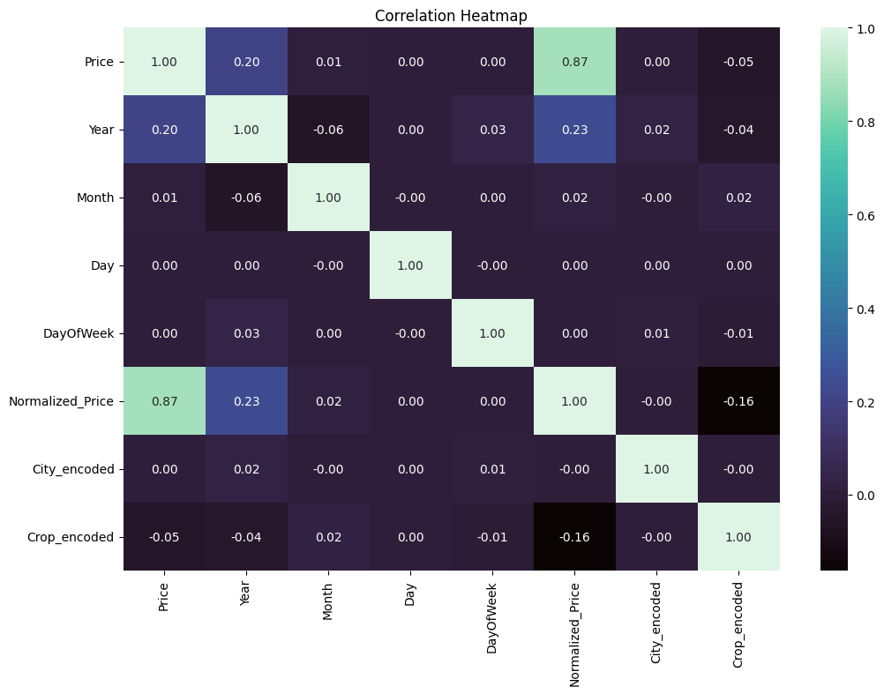  Fig 3. Feature Correlation Heatmap

M3 — Basic Time-Series Analysis
Selected Banana (DOZENS) in Vehari as the most data-rich series. Applied 7-day and 30-day moving averages alongside rolling statistics (mean and std) to characterize short-term trends, price stability, and volatility.

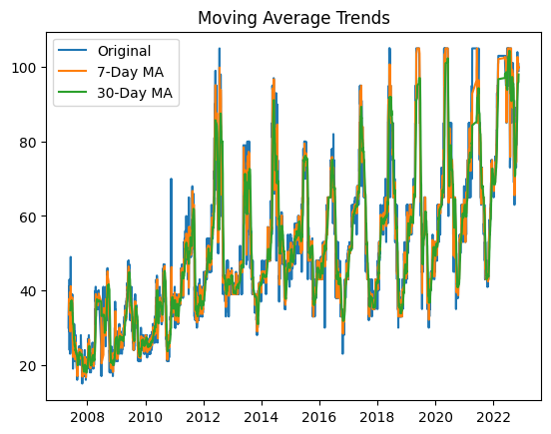  Fig 4. Moving Averages (7-Day & 30-Day) | 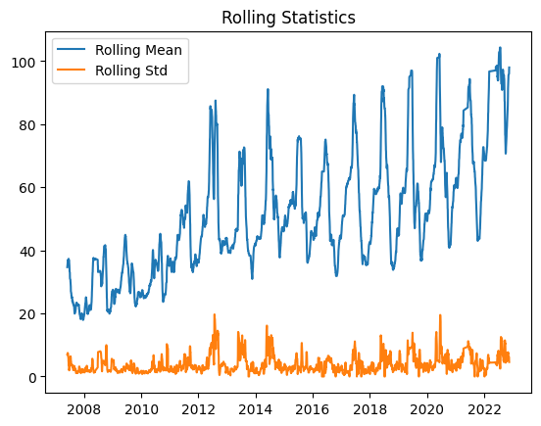  Fig 5. Rolling Mean & Std Dev (Volatility)

M4 — Advanced Time-Series Analysis
Extended analysis to the top 5 crops. Applied additive seasonal decomposition, ADF stationarity testing, and first-order differencing where required. Banana (DOZENS) and Garlic (China) were non-stationary and required differencing; the remaining three were stationary.

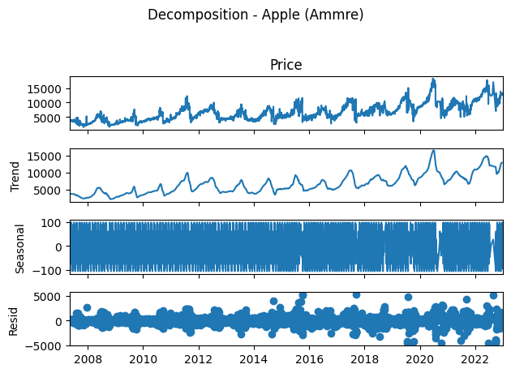  Fig 6. Seasonal Decomposition (Trend / Seasonal / Residual) | 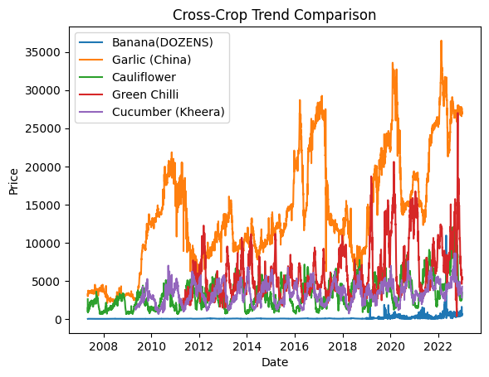  Fig 7. Price Trends Across Top 5 Crops

M5 — Temporal Feature Engineering
Built a model-ready feature matrix with 18 features: lag values (1, 3, 7, 14 days), rolling statistics, EMA, momentum features, cyclical month encoding, volatility, and group identifiers. Scaled with StandardScaler.

4. Key Findings So Far
- Prices exhibit strong monthly seasonality — several crops spike consistently in summer months, likely driven by supply-side climatic constraints.
- Green Chilli and Cucumber show the highest price volatility across cities, with rolling standard deviations significantly above the dataset mean.
- ADF testing revealed that 3 out of 5 top crops (Cauliflower, Green Chilli, Cucumber) are stationary in their original form, while Banana and Garlic required first-order differencing to achieve stationarity.
- The cross-crop trend comparison shows Garlic (China) has the steepest long-term upward price trend, while Cauliflower prices remain comparatively stable over the observed period.

5. Challenges Faced
- Irregular recording intervals — not all crop-city combinations have daily entries, creating gaps that complicate rolling window calculations and require careful forward-fill strategies.
- Price entries of zero were present in the raw data, requiring explicit filtering as they skew normalization and statistical summaries rather than representing genuine market values.
- Non-stationarity in several series — stationarity could not be assumed globally; ADF testing had to be applied per crop, and differencing applied selectively, adding complexity to the pipeline.

6. Progress Checklist
Task | Deliverable | Status
Dataset loading, validation & merging (53 CSV files) | Deliverable 1 | ✔ Done
Missing value handling & outlier removal (IQR) | Deliverable 1 | ✔ Done
Calendar feature extraction & price normalization | Deliverable 1 | ✔ Done
Exploratory data analysis (9 visualizations) | Deliverable 1 | ✔ Done
Basic time-series: moving averages & rolling statistics | Deliverable 1 | ✔ Done
Adv. time-series: decomposition, ADF test, differencing | Deliverable 1 | ✔ Done
Cross-crop trend comparison (top 5 crops) | Deliverable 1 | ✔ Done
Temporal feature engineering (18 features, scaled matrix) | Deliverable 1 | ✔ Done
ACF/PACF analysis & ARIMA model training | Final | ⏳ Pending
Holt-Winters Exponential Smoothing implementation | Final | ⏳ Pending
ML-Models: Linear Regression & Random Forest | Final | ⏳ Pending
Evaluation: MAE, RMSE, MAPE on temporal train-test split | Final | ⏳ Pending
Hyperparameter tuning & residual analysis | Final | ⏳ Pending
Clustering Analysis (if required) | Final | ⏳ Pending
Final comparative evaluation & trend insight extraction | Final | ⏳ Pending
Complete analytical report & visualizations | Final | ⏳ Pending

